Character Analysis:
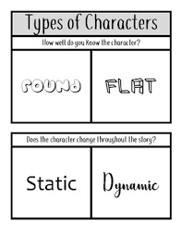
- Explain why Marji is a Round/Dynamic character in the story.
Cite SPECIFIC EVIDENCE from the book.

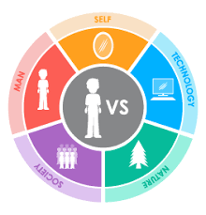

Conflict:

- Describe a conflict that was important to the story. Cite SPECIFIC EVIDENCE from the book.

- Graphic novels can have an added impact on readers that a normal book cannot. What are some of those impacts? Why do you think the author, Marjane Satrapi, chose graphic novel form instead of a normal text?

Graphic Novel Terms:
- Explain how graphic elements impacted page 89 in the story: layout, panel, frame, gutter, foreground, midground, background, speech balloon, hands & feet, faces, shading & color. Draw at least 3 lines to the specific elements and elaborate how they affected readers or the information being shared.

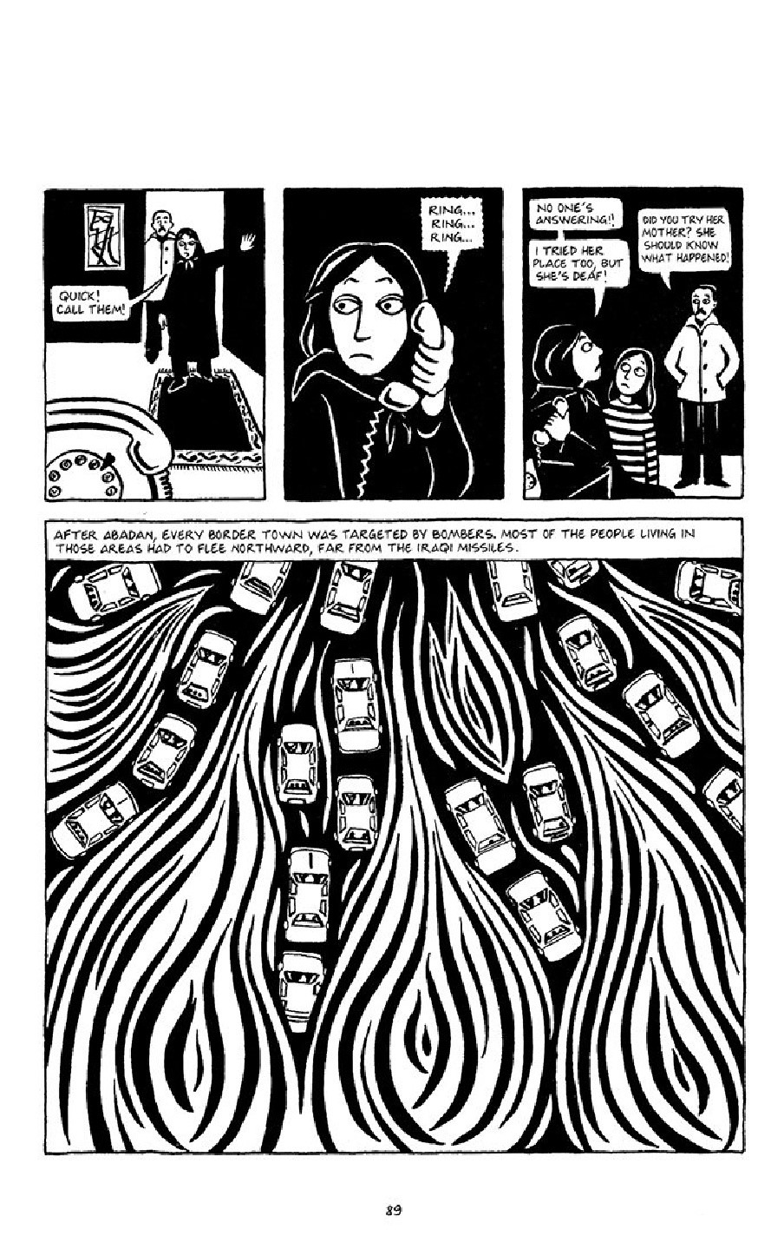

Name:_______________________________________________ Period:_____
Persepolis Writing Prompts
1. The author, Marjane Satrapi explains in her introduction to Persepolis that she wrote this book to show “an entire nation should not be judged by the wrongdoings of a few extremists” (Satrapi 2). How does Persepolis change or confirm your views on Iran? In what ways does reading this book deepen your understanding and knowledge of Iran’s history, the current situation in Iran, and the relationship between the U.S. and other countries?
2. “Every situation has an opportunity for laughs.” (p. 97) Give some examples of how the ordinary citizens of Iran enjoyed life despite the oppressive regime. What made you laugh? How does the author Satrapi add comic relief? How are these scenes relevant to the story as a whole? Why are these scenes important to include when discussing such a serious topic?
3. What kinds of captivity and freedom does the author write about in Persepolis? What stifles or prevents people from being completely free? How do Marji’s family and other citizens avoid and defy the rules imposed on them and attempt to live ordinary lives despite revolution and war? Give some examples of their small acts of rebellion and why they were important.
__________________________________________________________________________________________________________________________________________________________________________________________________________________________________________________________________________________________________________________________________________________________________________________________________________________________________________________________________________________________________________________________________________________________________________________________________________________________________________________________________________________________________________________________________________________________________________________________________________________________________________________________________________________________________________________________________________________________________________________________________________________________________________________________________________________________________________________________________________________________________________________________________________________________________________________________________________________________________________________________________________________________________________________________________________________________________________________________________________________________________________________________________________________________________________________________________________________________________________________________________________________________________________________________________________________________________________________________________________________________________________________________________________________________________________________________________________________________________________________________________________________________________________________________________________________________________________________________________________
____________________________________________________________________________________________________________________________________________________________________________________________________
____________________________________________________________________________________________________________________________________________________________________________________________________
____________________________________________________________________________________________________________________________________________________________________________________________________
____________________________________________________________________________________________________________________________________________________________________________________________________
____________________________________________________________________________________________________________________________________________________________________________________________________

REQUIRED SELF-REFLECTION—USE THIS RUBRIC TO GRADE YOURSELF BEFORE HANDING IN

Focus: | Success Criteria: | MY  score | TEACHER’S  score
Claim | A claim is provided by providing a comparison between the story and today
Evidence | Evidence is provided by including 2-3 examples from the story (either direct quote or paraphrase) and cited correctly
Reasoning | Writing is thoughtful, explained, connected, and a minimum of 8-10 sentences.
Overall:

